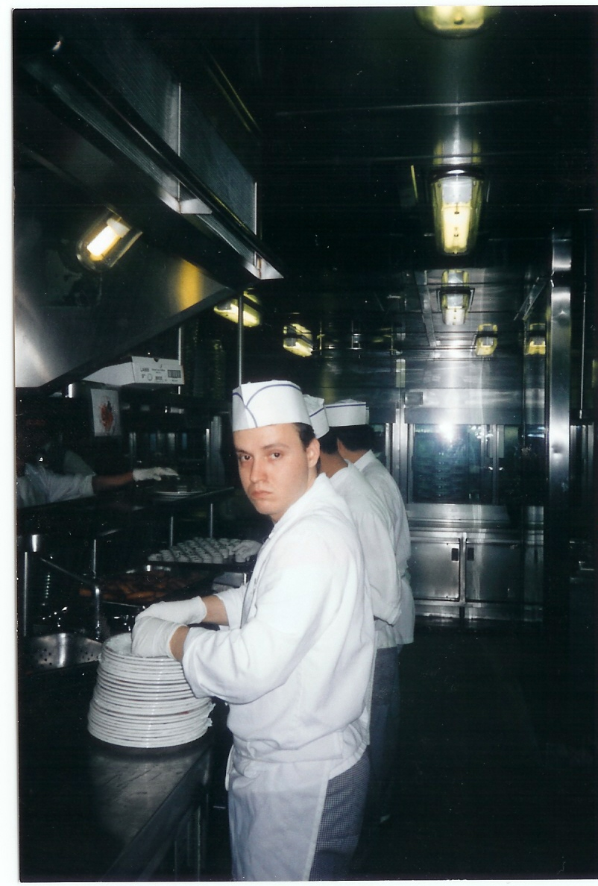
C U R R I C U L U M V I T A E

Name:
Age:
Address:
Phone:
E-mail:

Goals: Use my experience and language-knowledge
Work in an international environment
Widing my knowledge

Qualification: 1990-1994 Catering Technical School as cook
Language: Technical and Conversational English
Others: Driving license
Experiences: 1994-1995 Autós Restaurant (Dunaújváros)
1995-1996 (1 year) Hotel Antoanette Kensigton London,
1996-1997 (1 year) Soul Cafe Restaurant, Maidstone, England, small Italian restaurant with 150 seating capacity
1998-2001 Princess Cruises Ships Company, www.princess.com
2001- Castellum Restaurant, Dunaújváros, Hungary, seating capacity: 80, with international cuisine (Hungarian, Serb, English etc.)
Skills: decided, experienced
good sense of recognizing people
self-confident
charming temperament
Hobby: sport, driving,
get to know people, music
Professional Experience:

1995-1996 Hotel Antoanette Kensigton London, England:

The Hotel Antoanette’s restaurant was well-known by its high level quality food service in London. I was chef de partie so my work begun with the preparation of an english breakfast for around hundred people. In the evening times several parties were organized for the guests, where we had to fulfil the popular and the special food request as well. The menu included different soups, pork, beef dishes, and varied salads.

1996-1997 Soul Cafe restaurant, Maidstone, England

It was an italian restaurant with a hundred and fifty seats. I was working there as a first cook, and mainly we prepared italian lunch like pasta, pizza and other regional food. I was working with italian stuff where I have got known to work fast and thorougly.

1998-2001 Princess Cruises – Sea Princess:

First I was working as a second-cook on a cruise-ship on the Caribbean-sea between 1998-2001. The main dining room I worked for was open between 0-24 and I had to prepare the breakfast and lunch also. Generally the menu was changed every day, so I had got the experience to get a wild overview in the international food service. In the first couple months I was working at the fish - department, where I have got known the entire knowledge of the sea-food handling. I cooked crablegs, lobster tail, halibut, salmon, dover sole, shrimp also. After I was promoted to the main grill department. I was responsable to manage a group of three. We did the slicing, marinating and seasoning. During the service I had to grill the beef tenderloin, sirloin to the right temperature.

2001- Castellum Restaurant

After a hard and strict probation I was accepted as a chef to the one of the best restaurant in the county and have been working till the present days. There I cook lamb, beef, poultry and pork and special national soups. I help to figure out new menu as well.

